**Functional Document**

|  |  |
| --- | --- |
| **Application** | NGERP – Centra |
| **Service Bundle** | Sales Management |
| **Service Request** | Print Batch NTA AR Invoice |

**Description:**

In **Compiere (NGERP - Centra)**, the system should allow users to view and process only the current month's completed NTA AR invoices in the "**Print Batch NTA AR Invoice**" form.

**Workflow Process:**

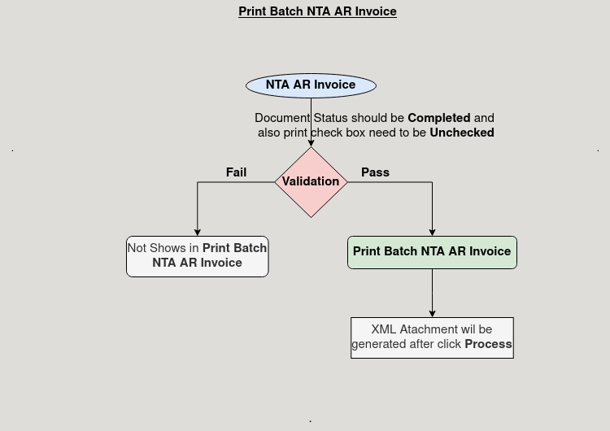

**Business Rules:**

* It is visible only in **HQ.**
* Here display only completed NTA AR invoices from the current month in the "Print Batch NTA AR Invoice" form.
* Users should be able to generate XML for both single and multiple NTA AR invoices.
* The "Print Batch NTA AR Invoice" form is supported for a Select All checkbox to process multiple invoices simultaneously.